Question 1a
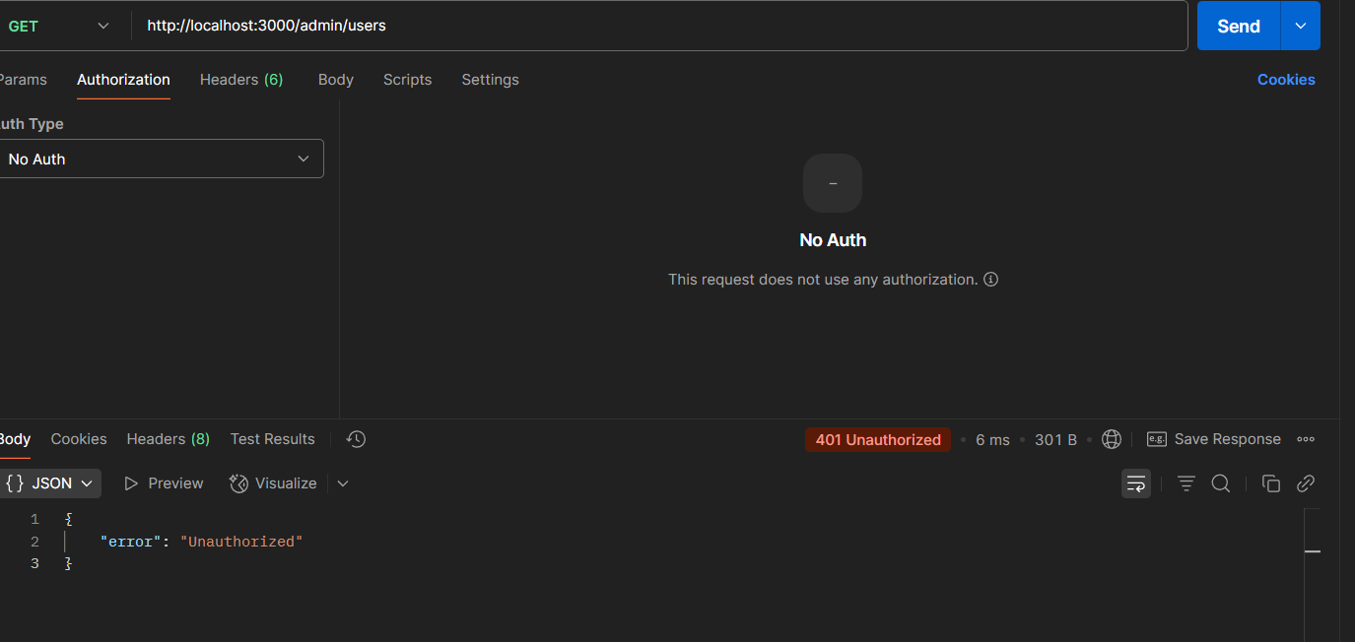

Question 1b
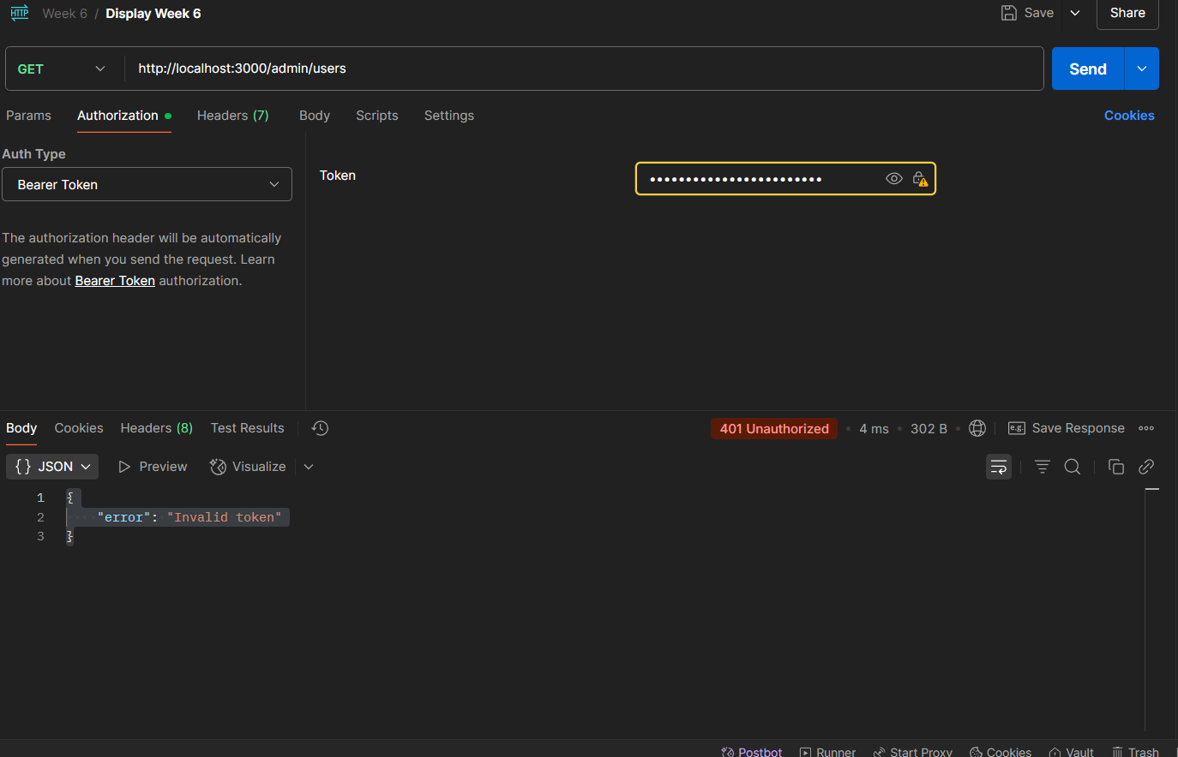

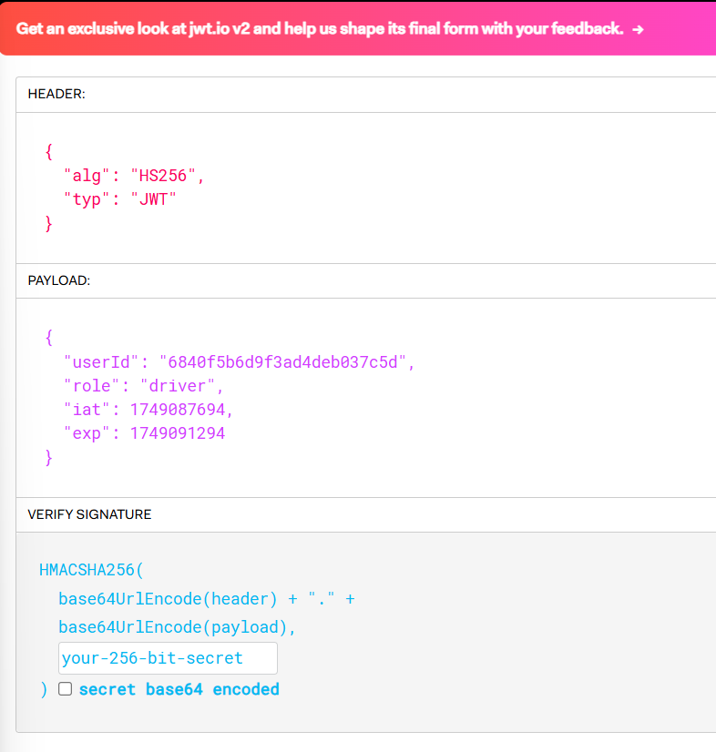
Question 1c
Header: It specifies the signing algorithm (HS256) and token type (JWT).
Payload: Contains the claims:
userId: The unique ID of the user.
role: The role of the user (driver in this case).
iat: The issued-at timestamp, showing when the token was created.
exp: The expiration timestamp, showing when the token will expire.
Signature: Ensures the token’s integrity by verifying it hasn’t been altered.
Question 2a
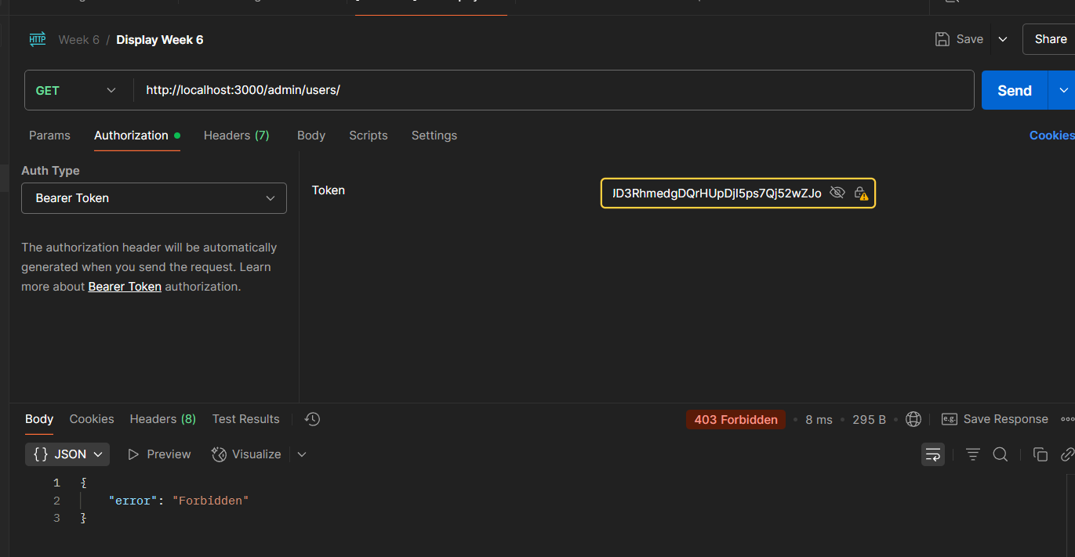

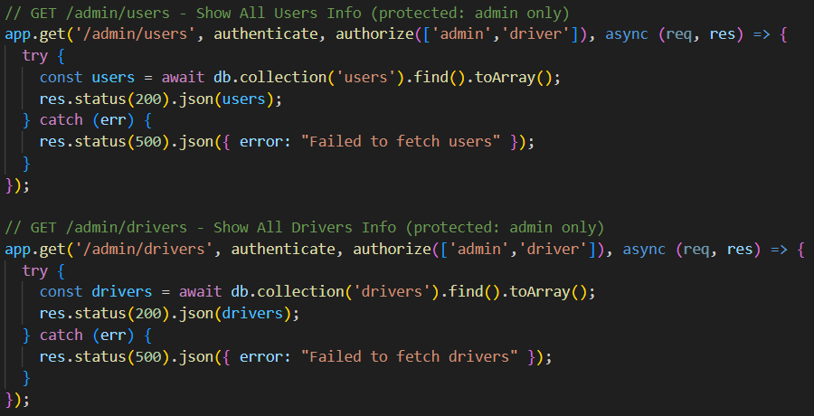
Question 2b
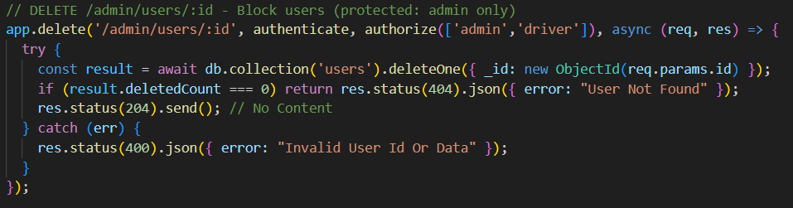
Question 3a
The Authorization header is more secure than placing the token in the request body or URL parameters because HTTP headers are less likely to be logged or exposed in transit compared to body data or URL query strings.

Question 3b
Password hashing makes passwords unrecoverable in the event of a compromise, hence protecting user data. It turns plaintext passwords into hashed values, which are one-way, irreversible, and frequently salted for further uniqueness. Even if hashed passwords are taken during a breach, they cannot be easily reversed to reveal the original password, making it far more difficult for attackers to get access to user accounts.

Question 4a
What is the purpose of the Bearer keyword in the Authorization header?

The "Bearer" keyword in the Authorization header is part of the OAuth 2.0 standard and is used to indicate that the token being sent is a bearer token.
A bearer token is a type of access token that allows the bearer (whoever holds the token) to access protected resources without needing further authentication.

Question 4b
